Online Book Store

(Website Name: Corner Book Store)

Team Members:

Paul Geevargheese Mathew – pxm142330

Contents

1. Description 3

2. Database Design: 4

3. Languages/Frameworks 6

4. Use cases 7

5. Screen Shots 10

5.1 Login screen 10

5.2 Signup screen 11

5.3 Add book 11

5.4 After Add 12

5.5 Delete book 12

5.6 After Delete 13

5.7 List All for admin 13

5.8 Before Update 14

5.9 Edit page 14

5.10 After Update 14

5.11 User Home page 15

5.12 Shopping Cart 15

5.13 History 16

5.14 Book Management 16

5.15 Item Management 17

5.16 Category Management 17

6. Work Division 18

# Description

Online Book store is an online web application where the customer can buy books online. The customers can browse through the listed books in the website, once they finalized their decision, they will add the desired items in their shopping cart before making the final check out from there.

The user can login using his account details or new customers can set up an account very quickly by providing the information like Full name, Email, Password. After the validation of the input fields, the user will be given an account in the site. The account details include name, contact number and shipping address. Though having an account is not necessary, it will be easy for the user to keep track of his purchase history. The books are divided into many categories based on subject like Fiction, Science, Literature, and Technology etc. The user can search the book by its title or by filtering its category. They can edit the shopping cart entries at any time before the final purchase. Once the purchase is made, they can keep track of the books they bought under the history option.

The Administrator will have additional functionalities when compared to the regular user. He can add\ delete\update the book details, book categories (used, new, rent), and their quantity management in the inventory. The corresponding stack quantity will be updated simultaneously once the items are checked out. Similarly if any of the items become out of stock, the users will be notified.

The version of the website can be accessed at http://finalproject-paulgmathew.c9users.io/login.

# Database Design:

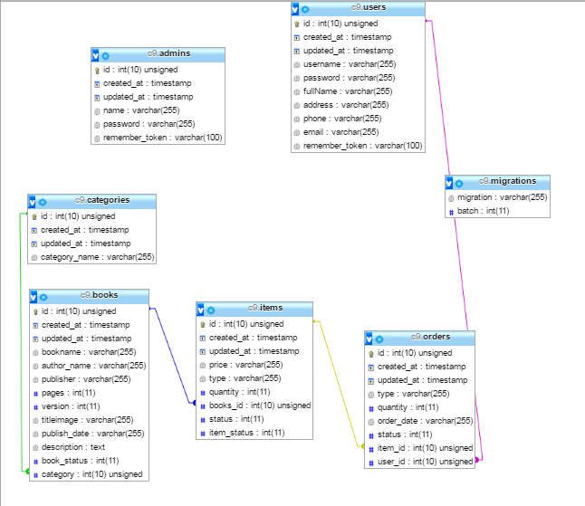

 => Primary Key  => Varchar values

=> Foreign key references  => Integer values

 => Time Stamp Values

# Languages/Frameworks

* Languages: - PHP, HTML, CSS, jQuery, MySQL, Ajax.
* Framework :- Laravel 5

# Use cases

**Users:**

1. Sign up

• Purpose: To create an account in the website.

• Actor: User

• Input: The user will enter details in the registration form according to the required fields. The fields include

1. Username 2. Full name 3. Password 4. Confirm password 5. Email

• Output: After the successful validation of inputs, the requested account will be created.

1. Login

• Purpose: If the user wants to get access to all the functionalities of Online Book Store he should login using his username and password.

• Actor: User

• Input: The user will enter his username and password.

• Output: If it is a successful login the user will be directed to the main home page. Else if the user enters invalid information the login error will be displayed.

1. Manage Account

• Purpose: If the user wants to change his personal account information then he can update his selected fields and the entire data will be updated in the data base through an update query.

• Actor: User

• Input: The user will update his account information.

• Output: The system will update the entered information in the database using an update query.

1. View History

• Purpose: If the user wants to view his purchase history, he can view it by clicking the history button at the top and the results were retrieved from the data base through a select query.

• Actor: User

• Input: The user will click the History button at the top right of the page.

• Output: The system will retrieve the information and the user can see the purchase history.

1. Search

• Purpose: If the user wants to search/browse the books by its title or category, he can view the results which will be retrieved from the data base through a select query.

• Actor: User

• Input: The user will search either by entering text in the text box at the top right or filter by its category on the left pane of the page.

• Output: The system will retrieve the information and the user can see the relevant results.

1. Logout

• Purpose: If the user wants to end his session and sign out of the website then he can use the logout option.

• Actor: User

• Input: The user will click the logout button.

• Output: The user’s account session comes to an end and he should login again if he wants to enter into the website.

**Manage Shopping Cart:**

1. Add to Shopping Cart

• Purpose: If the user wants to purchase a book then he can place an order by selecting the book and adding it to the shopping cart.

• Actor: User

• Input: The user will enter the quantity required and add to his shopping cart.

• Output: The items will be added to the user’s shopping cart.

1. Edit Shopping Cart

• Purpose: If the user wants to change the entries in his shopping cart.

• Actor: User

• Input: The user will click buy/delete button in the shopping cart summary to edit his order details.

• Output: The updated order details are reflected in the shopping cart summary.

1. View Shopping Cart

• Purpose: If the user wants to view the items he added to the shopping cart then he can click the shopping cart link at the top of the page.

• Actor: User

• Input: The user will click the shopping cart link.

• Output: The user’s shopping cart summary will be displayed in the form of a tabular format with all the books and their quantity. A total cost of all the items is also displayed.

1. To make a purchase

• Purpose: If the user wants to check out the items in the shopping cart.

• Actor: User

• Input: The user will click the shopping cart button and update the details if he want then can make a purchase by clicking the buy button in the cart

• Output: The items will be removed from his shopping cart and added to his history. . The relevant item quantity will be updated in the item list in the inventory.

1. To delete the items in the cart

• Purpose: If the user wants to remove the items in the shopping cart.

• Actor: User

• Input: The user will click the shopping cart button and then by clicking the delete button in the cart.

• Output: The items will be removed from the user’s shopping cart.

**Administrator:**

1. Login

• Purpose: If the Administrator wants to get access to all the functionalities of Online Book Store he should login using his username and password.

• Actor: Administrator

• Input: The Administrator will enter his username and password.

• Output: If it is a successful login the Administrator will be directed to his main page. Else if the Administrator enters invalid information he will be asked to check the entered information.

1. Add/Delete/Update Book

• Purpose: If the Administrator wants to add, delete or update a book then he can do so by using his administration rights and the book table will be updated in the database.

• Actor: Administrator

• Input: If the Administrator wants to add a book the he should click the add button in the book page and fill the related fields to the book. If he wants to delete a book he can click the delete button to remove it from the database. To update an entry, he should click the book id link in order to open the entry and can update it.

• Output: The updated books list will be displayed in the main home page under their category.

1. Logout

• Purpose: If the Administrator wants to end his session and sign out of the website then he can use the logout option.

• Actor: Administrator

• Input: The Administrator will click the logout button.

• Output: The Administrator’s account session comes to an end and he should login again if he wants to enter into the website.

# Screen Shots

# 5.1 Login screen

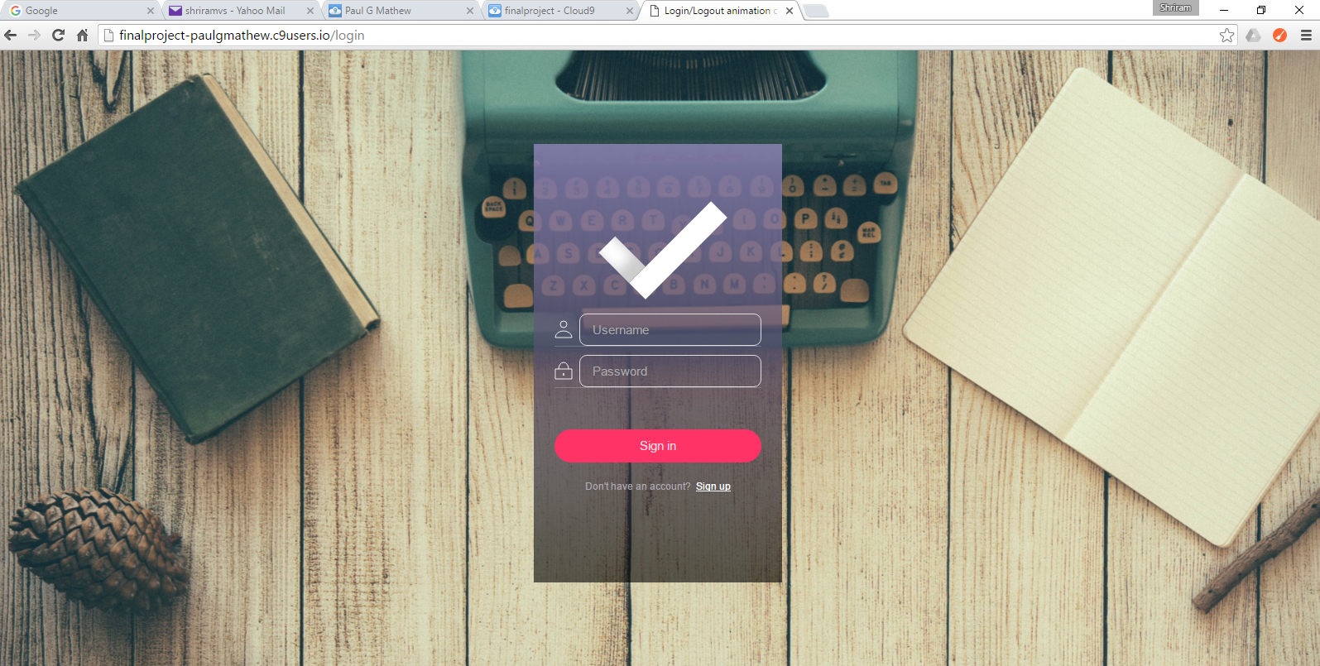

# Signup screen

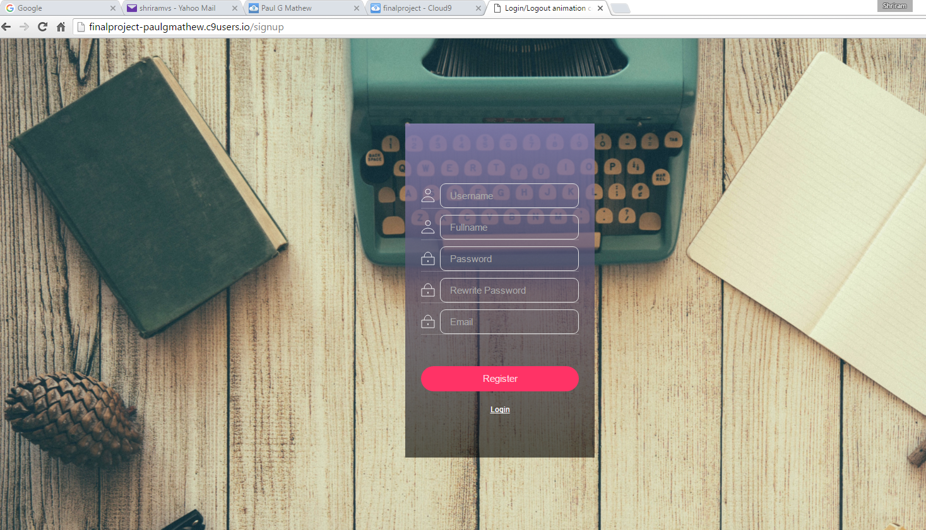

# Add book

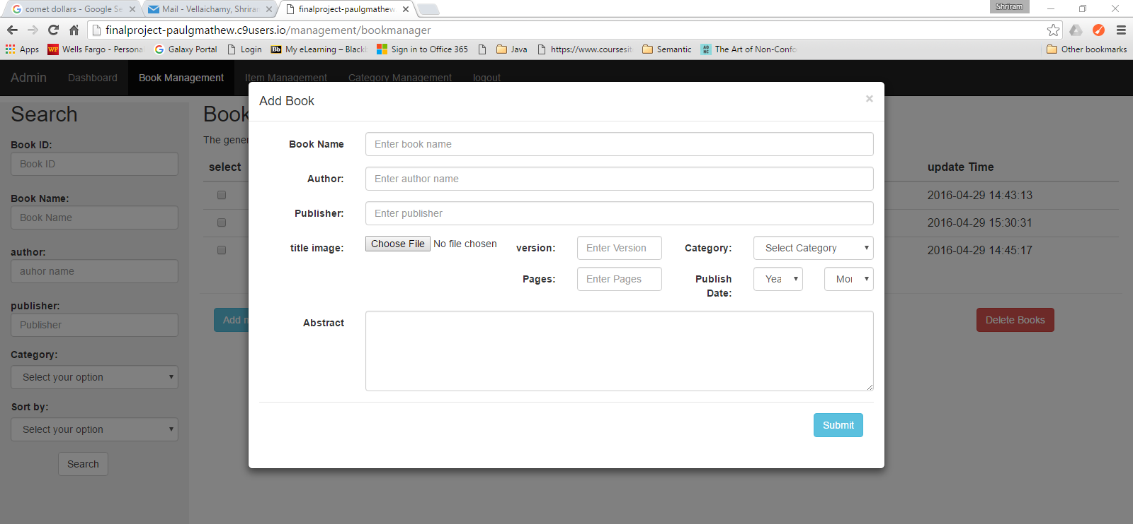

# After Add

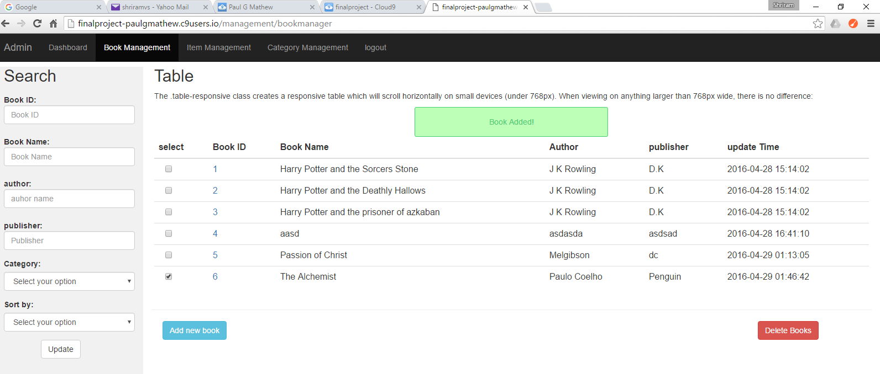

# Delete book

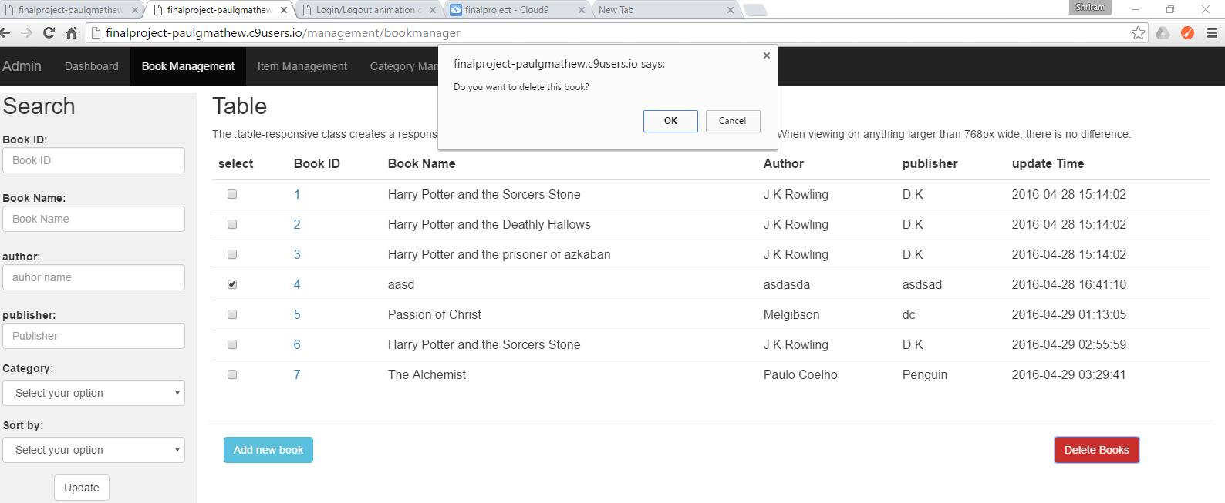

# After Delete

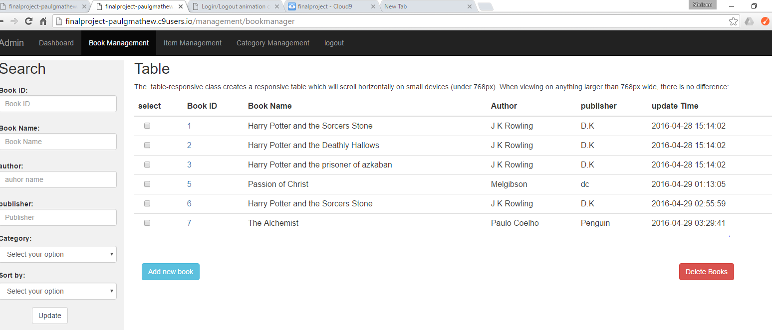

# List All for admin

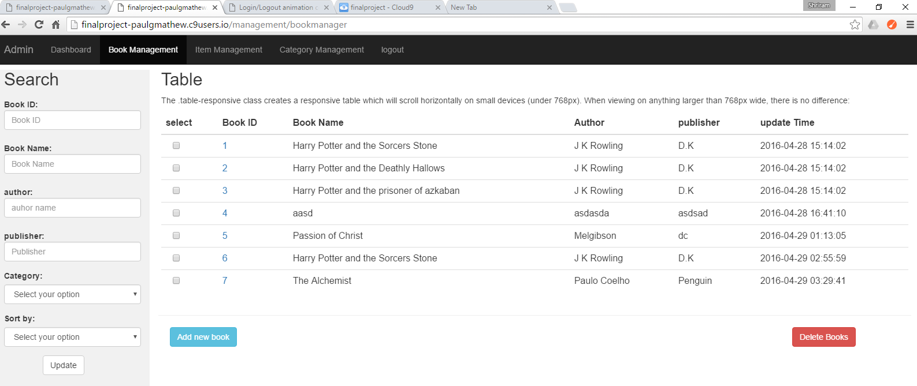

# Before Update

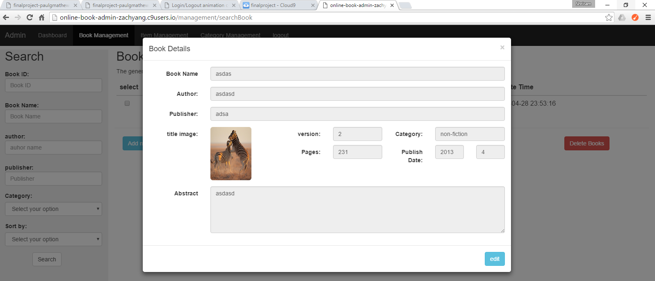

# Edit page

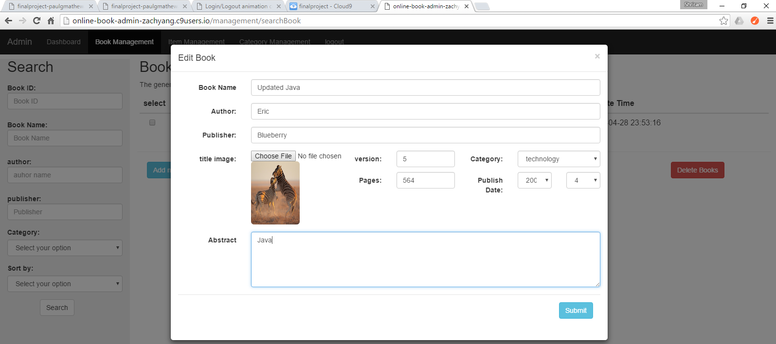

# After Update

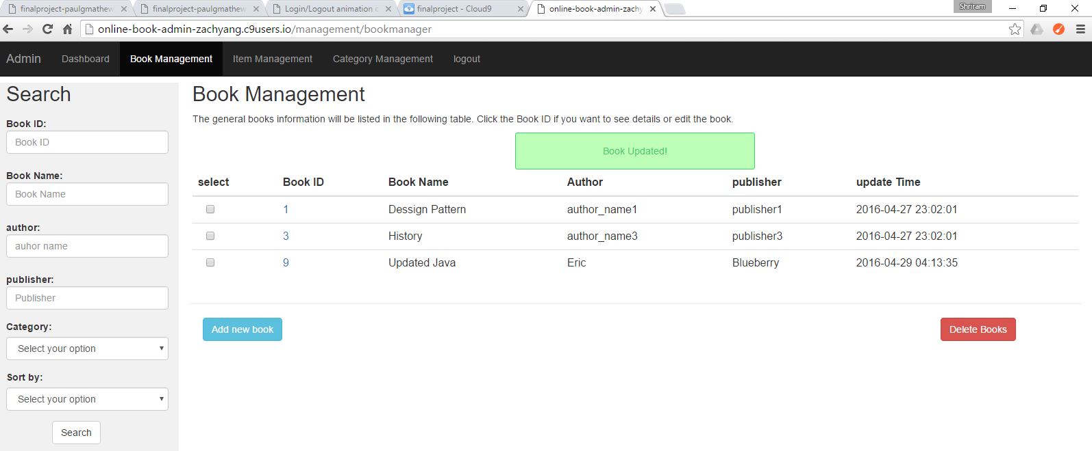

# User Home page

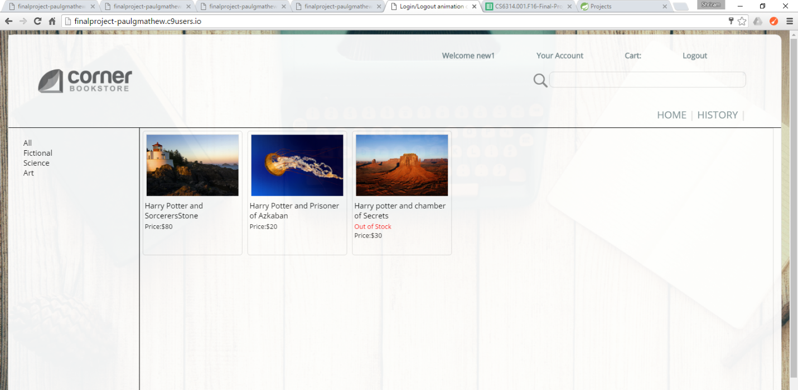

# Shopping Cart

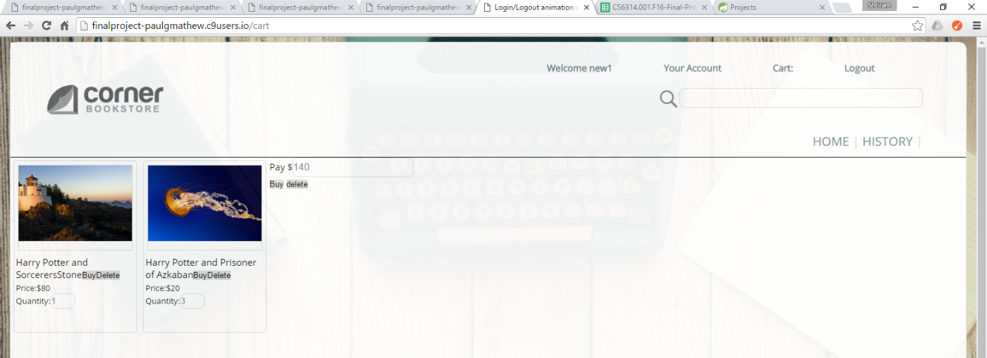

# History

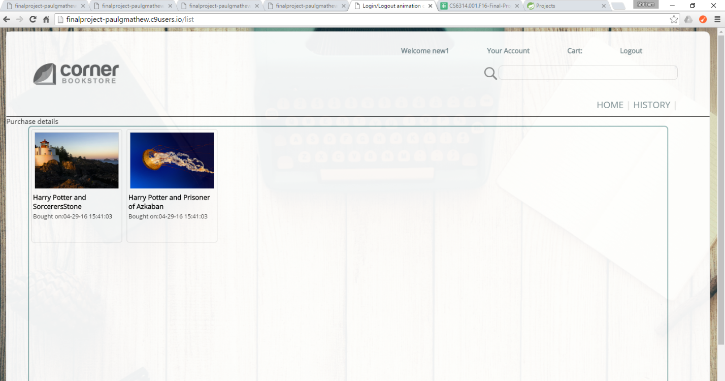

# Book Management

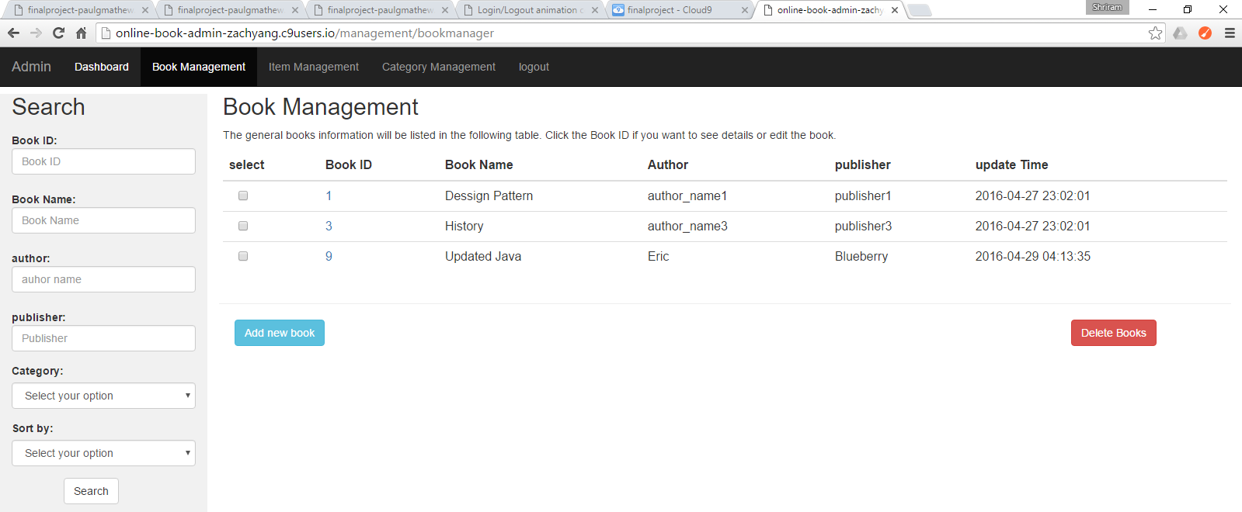

# Item Management

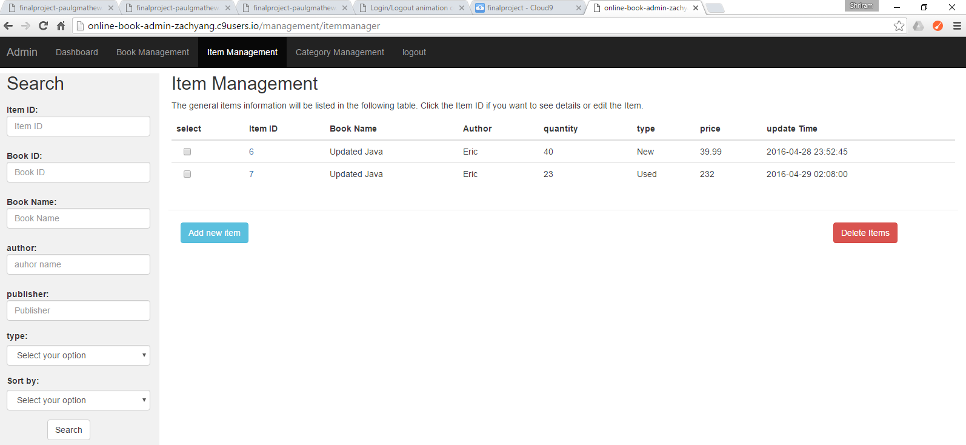

# Category Management

